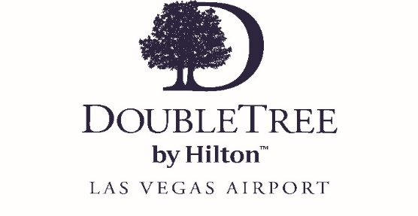
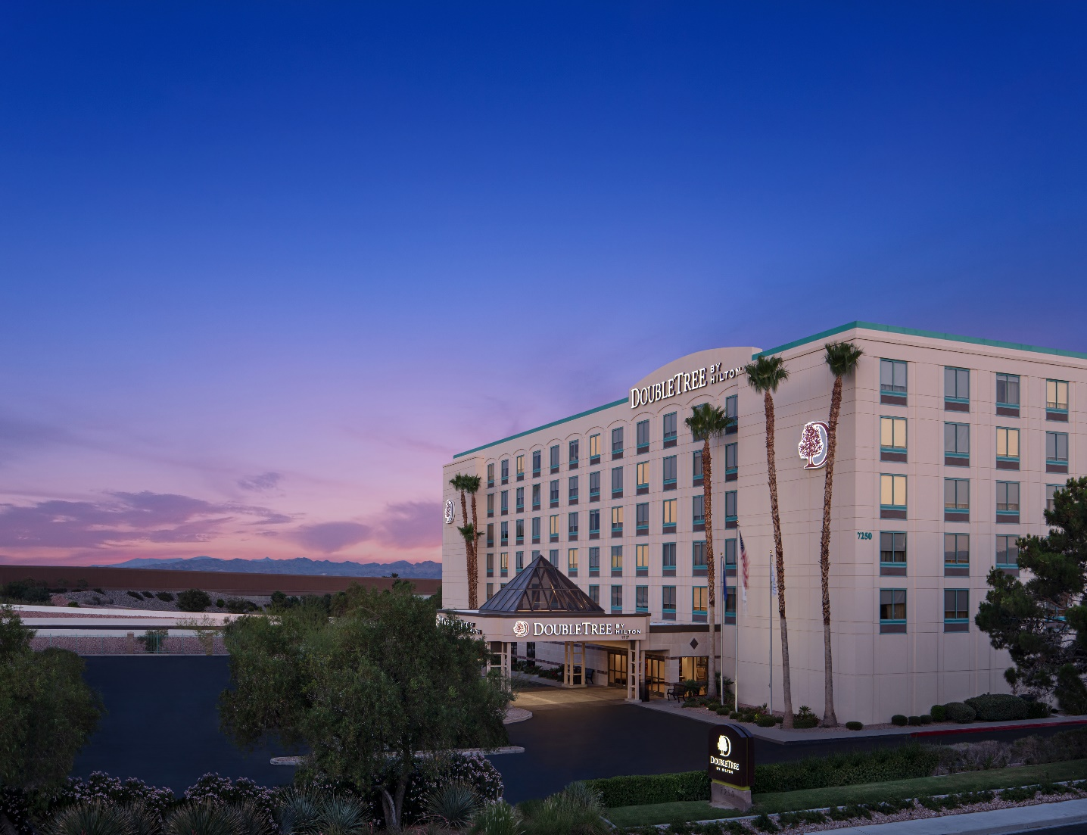
2023 Durango Fall Classic
September 21-23, 2023

- $157.00 for a King rooms
- $169.00 for a room with Two Double beds

  - Rates include Buffet Breakfast
  - Rates include parking
  - Year Round Heated Pool
  - Free Wi-Fi

For group bookings please contact Brooke Welton at (702) 932-1059 or email her at Brooke.Welton@Hilton.com

For individual bookings please CLICK the below link

DURANGO FALL CLASSIC

***Rates are based on availability***

